ASSIGNMENT 5.4
Name: S.ROHITH
H.T.NO:2303A52262
Batch:43

Task 1:
Prompt GitHub Copilot to generate a Python script that collects user data (e.g., name, age, email). Then, ask Copilot to add comments on how to anonymize or protect this data.
Expected Output #1:
A script with inline Copilot-suggested code and comments explaining how to safeguard or anonymize user information (e.g.,
hashing emails, not storing data unencrypted).
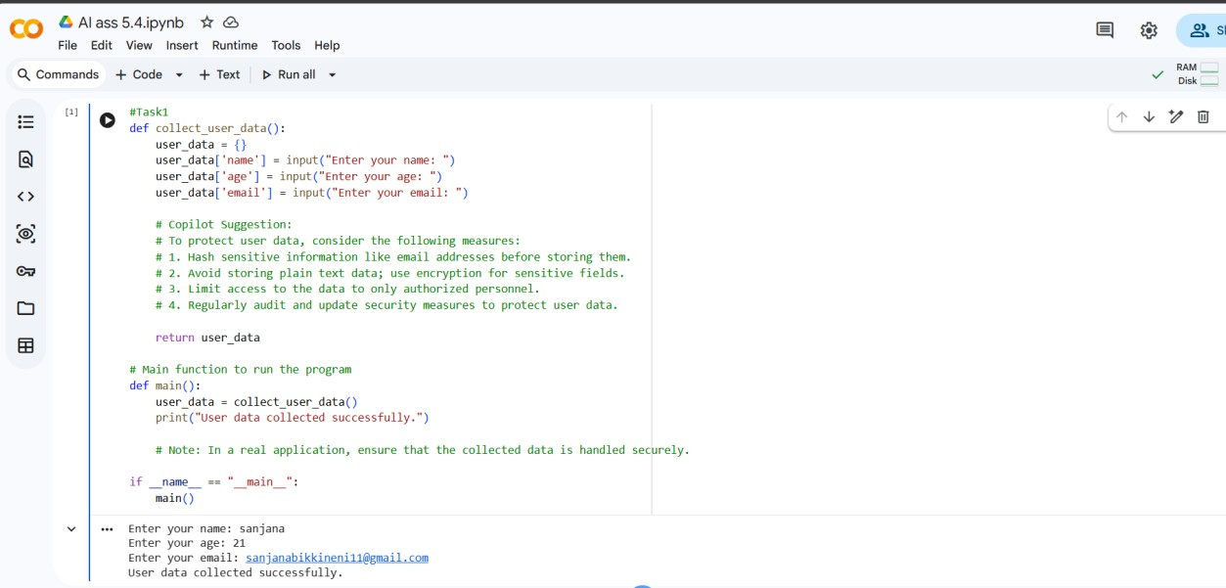
Task 2:
Ask Copilot to generate a Python function for sentiment analysis.
Then prompt Copilot to identify and handle potential biases in the
data.
Expected Output #2:
Copilot-generated code with additions or comments addressing bias mitigation strategies (e.g., balancing dataset, removing
offensive terms).
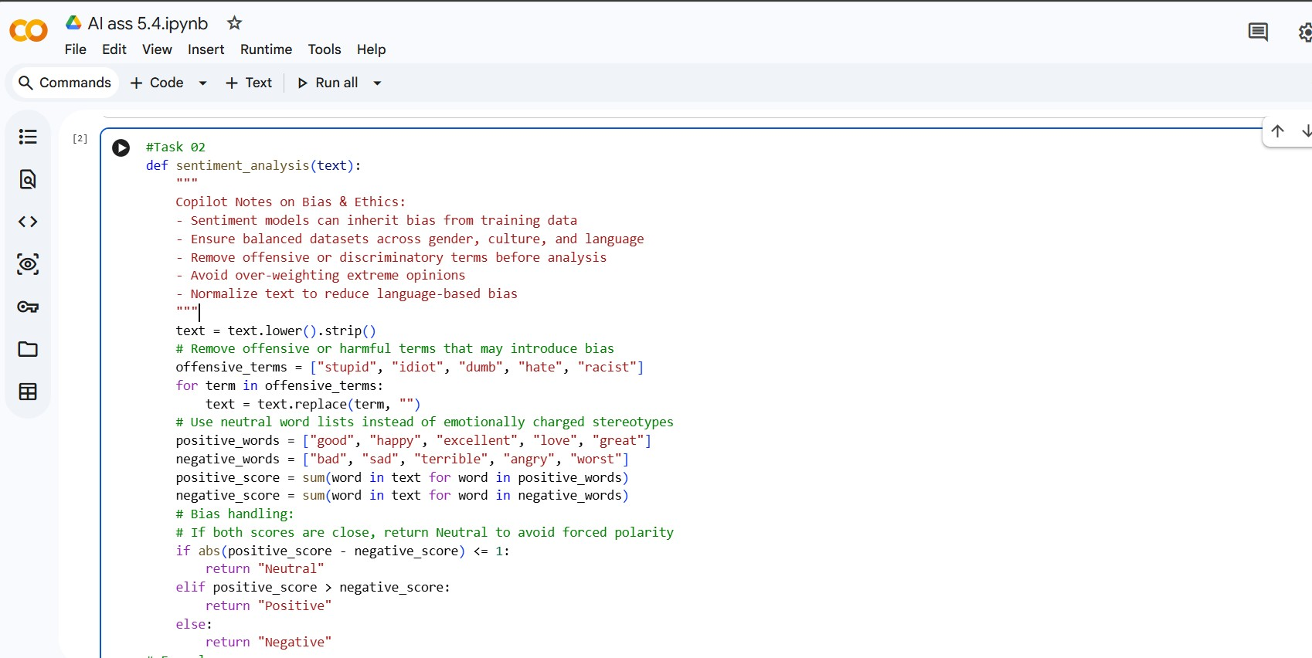

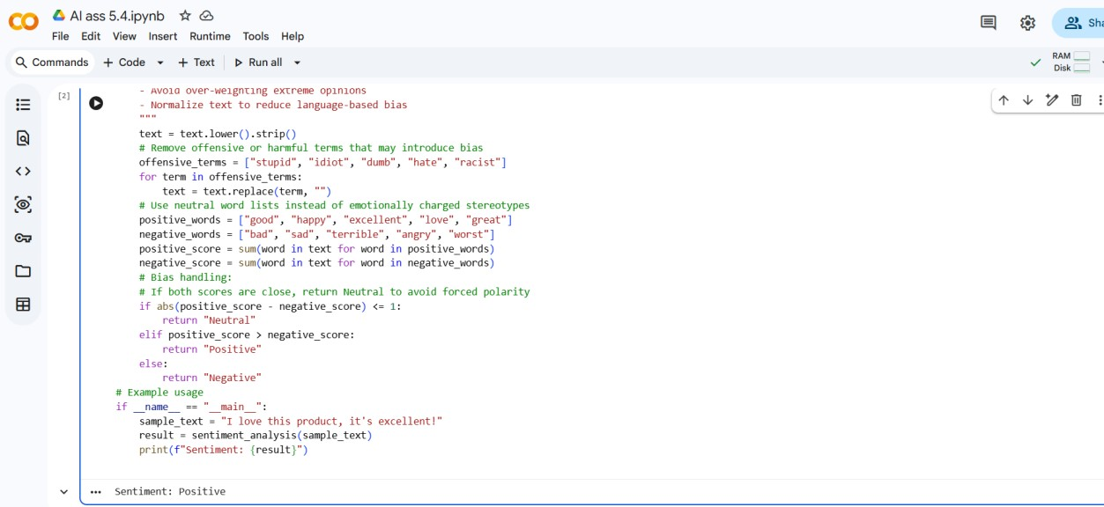
Task 3:
Use Copilot to write a Python program that recommends products based on user history. Ask it to follow ethical guidelines like transparency and fairness.
Expected Output #3:
Copilot suggestions that include explanations, fairness checks
(e.g., avoiding favoritism), and user feedback options in the code.
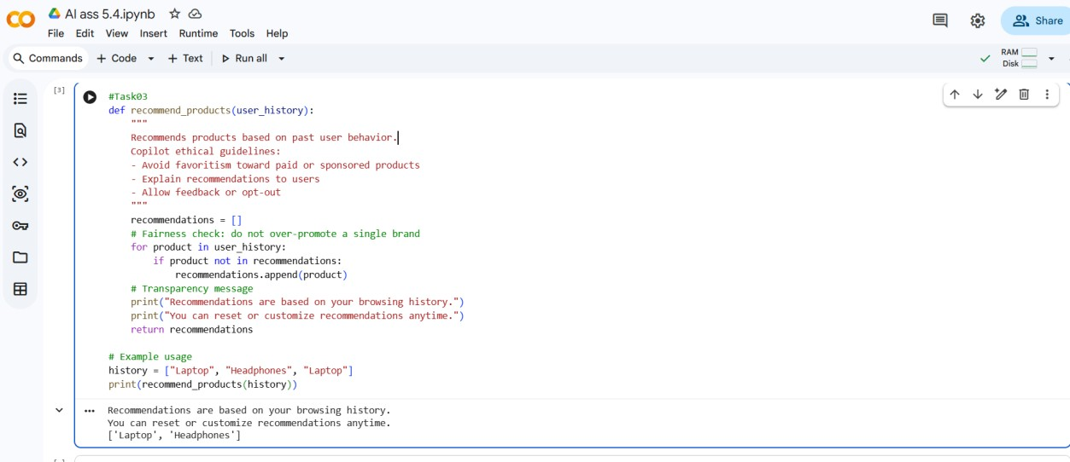
Task 4:
Prompt Copilot to generate logging functionality in a Python web application. Then, ask it to ensure the logs do not record sensitive information.
Expected Output #4:
Logging code that avoids saving personal identifiers (e.g., passwords, emails), and includes comments about ethical logging practices.
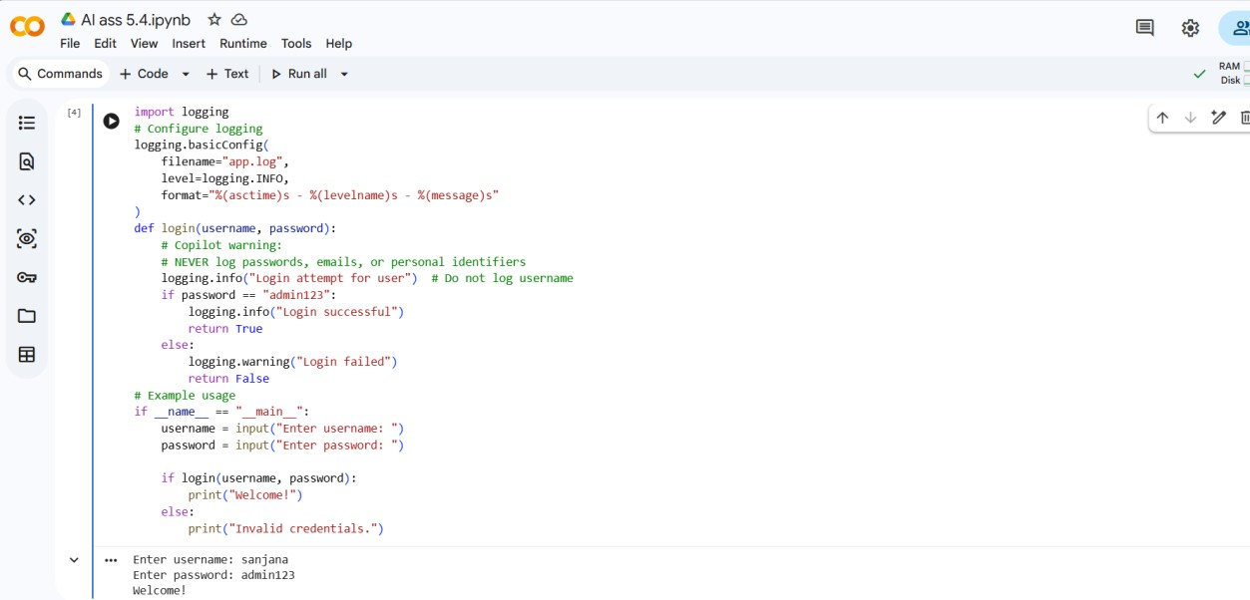
Task 5:
• Ask Copilot to generate a machine learning model. Then, prompt it to add documentation on how to use the model responsibly
(e.g., explainability, accuracy limits).
Expected Output #5:
• Copilot-generated model code with a README or inline documentation suggesting responsible usage, limitations, and
fairness considerations
